Own Arrangement Service on Healing and Wholeness

Introduction

The aim of these notes is to enable congregations and those organising Own Arrangement services to explore and experience healing and wholeness through an act of worship.
Included are suggestions for interpretation of the bible passage, ideas for a visual focus (objects and pictures) and practical activities along with suggestions for prayers, hymns, songs and other music.
Draw together a group of people to work through the resources here and to decide what will work best for your situation. The selections you make and the way you use these is up. This can be a most valuable time for the individuals involved and lead to growth in understanding and faith.
Remember that you are preparing a service of worship. Pray about it and listen for the Spirit’s guidance. You may want to follow a traditional order (hymn sandwich) or you may want to try doing things differently. If you vary the order from what the congregation are used to, they will find it helpful to be given an order of service (a kind of comfort blanket in the midst of change!). Do include somewhere a time of adoration and praise, a time of confession and absolution, the bible reading, a time of thanksgiving and intercession and the Lords’ Prayer. You may also want (or your treasurer may want you) to include an offering.

- What is Healing and Wholeness and how do you do it?

Healing was central to the ministry of Jesus. It was a sign of God’s kingdom, bringing renewal and wholeness of life to those who turned to God in their need. Jesus sent out his disciples with the commission to ‘proclaim the kingdom of God and to heal’ (Luke 9:2).
In every act of worship, the Church celebrates the grace of God who desires wholeness of body, mind and spirit for all people. At a service of healing, we focus on that aspect of God’s character. We bring to God our own frailty and brokenness – felt not just in physical illness but in guilt anxiety, and all the burdens which weigh us down, We also bring out concerns for others and for the world. Above all, we come to the God who knows our needs before we ask, and whose love revealed in Jesus Christ is stronger than suffering and death.
(Methodist Worship Book)
Healing and Wholeness services often include the laying on of hands or anointing with oil. This service uses neither of these.
- Putting the service together

Because these notes are intended to help you put together an Own Arrangements service, it isn’t possible to have a sermon as such (for which Methodism requires an accredited preacher) but look upon that as an opportunity to do something different.
This service focuses on touching. The story of the woman with the haemorrhage who reached out is sandwiched into the story of the healing of Jairus’ daughter who waited on the touch of Jesus.
Jesus’ healing comes to us when we reach out for it and when we feel unable to do anything but wait for his touch to come to us.
Try the role play first, then you may like to give a bit of explanation around the Jewish laws of cleanliness and prayer shawls.

Reading:
Matthew 9:18–26, or Mark 5:21 – 43, or Luke 8:40–56
The Matthew version is shorter and probably the best to read before the role play, but do read the others as part of your preparation as they help to build up a picture of what was going on.

Matthew 9:18–26
¹⁸ While he was saying these things to them, suddenly a leader of the synagogue came in and knelt before him, saying, ‘My daughter has just died; but come and lay your hand on her, and she will live.’ ¹⁹And Jesus got up and followed him, with his disciples. ²⁰Then suddenly a woman who had been suffering from haemorrhages for twelve years came up behind him and touched the fringe of his cloak, ²¹for she said to herself, ‘If I only touch his cloak, I will be made well.’ ²²Jesus turned, and seeing her he said, ‘Take heart, daughter; your faith has made you well.’ And instantly the woman was made well. ²³When Jesus came to the leader’s house and saw the flute-players and the crowd making a commotion, ²⁴he said, ‘Go away; for the girl is not dead but sleeping.’ And they laughed at him. ²⁵But when the crowd had been put outside, he went in and took her by the hand, and the girl got up. ²⁶And the report of this spread throughout that district.

Role Play:
Read the bible reading.
Divide the congregation into groups of 5 (or 6).
Explain that in each group, one person is to be Jesus, one is Jairus, one is the woman, at least one is a disciple of Jesus, one is a member of the crowd.
Ask them to talk about their feelings as the events unfold.
Do not allow access to the bible for this, but you may want to read the story a second time before splitting into groups for discussion.
Allow around 10 minutes then regroup and ask each character in turn for their feelings (i.e. ask all those being Jesus, then all the women, etc).

Meditation from the woman’s perspective
My name was not mentioned, but that was normal. After all, I was a Jewish woman. But that was not so important, it was the least of my worries. I knew what I wanted. Healing! For nearly forty years, sickness had taken over my life - a haemorrhage which seemed incurable. I had searched everywhere for healing; had been to doctor after doctor, surgeon after surgeon. All my money was gone and healing was still not within my reach.
I was desperate! Someone had told me about Jesus - the Teacher who healed. I had to meet this Jesus. He might well be the one who could heal me. It was time to meet him. But how could I reach Him? They told me he was a crowd puller. The people in the crowd knew me. Someone would spot me in the crowd and shout, 'unclean!'
Jesus did come to my town one day. I could not resist meeting Him. I needed healing so badly. And so I plucked up courage. I made my way through the crowd. My aim was to get as close to Jesus as possible. It was difficult for me to stand in front of Him and make my request. I had an idea - I would hold on to the hem of his garment, and was sure that it would be my moment of healing.
Pushing through the crowd, I got behind Jesus and touched the hem of His garment holding on to the tassels - a representation of the law, which had declared me unclean because of my haemorrhage. I immediately felt different. I knew He had healed me. What the law could not do, Christ had done for me! Christ who had come to fulfil the law had set me free from my haemorrhage.
Then suddenly, I heard Jesus asking, “Who touched me?” “Healing power has gone out of my body”, he said. The disciples could not understand. They argued with him but Jesus knew someone had received healing. Again I plucked up courage and came and knelt before him. Jesus was so gracious! He simply said to me, “Go your way sister, your faith has made you well!” What joy was mine!!
We too can meet Jesus in the pressures that life brings our way; press through these to touch by faith the hem of Jesus’ garment and be made whole again!

©Olufemi Rose Cole-Njie 2012, used with permission.

Background information you may wish to share:
Jewish laws around cleanliness
Have a look at Leviticus 15:25-30 which outlines the rules around the woman’s haemorrhage which had been going on for twelve years. Living in this condition must have caused her great shame and also rejection by others who would be loath to contract uncleanliness from her. Twelve years – but she had not given up hope. She dared to come and mingle in a crowd of people of people where she may have been recognised, but she had a faith that Jesus could and would heal her.
She came as she was, hiding amongst the crowd and no doubt she expected to be able to hide away afterwards as well, but Jesus takes her shame away and asks her to come out of the shadows and meet him.
We need to seek God in the only way we can – from the place where we are, assured that Jesus pays attention to the most isolated of individuals.

Prayer Shawls
In the version of the story in Matthew’s and Luke’s gospel, the woman with the haemorrhage touched the fringe of Jesus’ cloak.
In Numbers 15:37-41 we read of the origin of the tassles on the prayer shawl or tallit.

³⁷The Lord said to Moses: ³⁸Speak to the Israelites, and tell them to make fringes on the corners of their garments throughout their generations and to put a blue cord on the fringe at each corner. ³⁹You have the fringe so that, when you see it, you will remember all the commandments of the Lord and do them, and not follow the lust of your own heart and your own eyes. ⁴⁰So you shall remember and do all my commandments, and you shall be holy to your God. ⁴¹I am the Lord your God, who brought you out of the land of Egypt, to be your God: I am the Lord your God.
(Also see Deuteronomy 22:12)

For the Jews, right from the time of Moses, wearing tassels throughout the day helped you to remember that you were one of God’s people.

Many Jews today wear a prayer shawl or tallit in order to keep this commandment. The tallit has special twined and knotted fringes known as tzitzit attached to its four corners. These today have 5 knots in them representing the 5 books of the Torah (Our first five books) and the four spaces between them represent the four letter for God’s name YHWH.
Along the shawl there are also 613 knotted strings to remind them of the 613 laws of the torah.
The use of the tallit began around 1800 BCE. The ancient Jewish tallit design was a large white rectangular garment with tzitzit in each corner and was used as a garment, bed sheet, and burial shroud.
Was it the fringe of a tallit, the symbol of being one of God’s people, that the woman touched for healing?
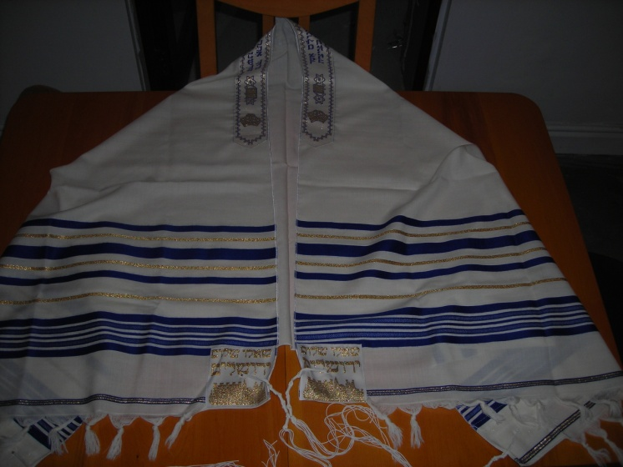

Response:
There are two responsive actions suggested here but you may be able to think of others based around fringes.

Making a prayer fringe together
Give everyone a length of wool about 30cm (12 inches) long.
Have a string suspended and accessible in the worship space with some pieces of wool already tied to it form the start of a fringe.
Introduce a time of prayer, perhaps use one of the suggested prayers, and then either play some quiet music or sing repetitively StF 651, Lord of life, we come to you,
during which people can come forward and tie their piece of wool to the string, adding to the fringe. Encourage them to run their fingers through the fringe bringing any requests for healing and wholeness to God.

Individual fringes (see illustrations)
For each person present, you will need a long length of wool (about a metre or three feet) and a short piece. Also a pair of scissors.
Play some quiet music.
Encourage the people to wind the long piece of wool round and round your hand to make lots of loops while bringing to God the situation(s) where healing and wholeness is needed. Then use the short piece to tie these tightly together.
Hold these tied loops prayerfully in your hands.
Take the scissors (this can be done individually or by those leading the worship) and cut the loops (to one side of the knot) to form a tassle, symbolising the releasing and freeing love of God.
Run your fingers through the wool of the tassle and accept the healing love of God coming to you where you are.
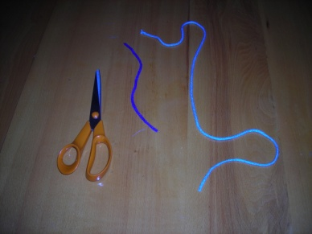
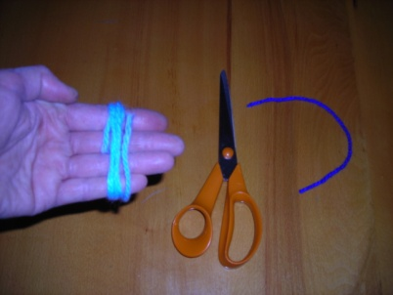
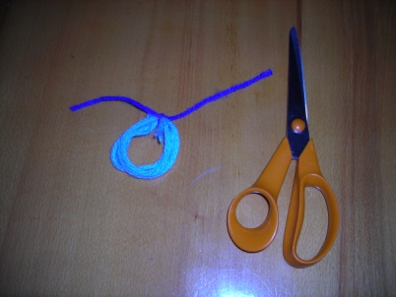

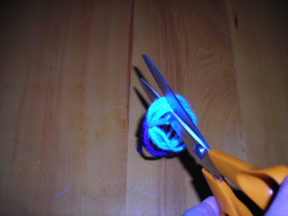
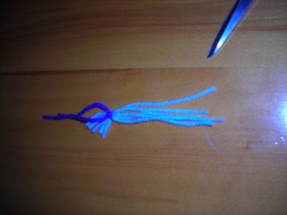

Hymns:
Singing the Faith
77 Give thanks to the Lord (his love endures forever)
156 From the breaking of the dawn
250 Jesus calls us! O’er the tumult
317 At the name of Jesus
530 To be in your presence
622 When our caring love grows thin
632 I’ve had questions without answers
650 Heal us, Immanuel! Hear our prayer
653 O Christ, the Healer, we have come
686 Jesus, Lord, we look to thee

also look at the section on Repentance and Forgiveness 419 – 438
and the section on Reconciliation, Healing and Wholeness 646-658

Hymns and Psalms
151 When Jesus the healer passed through Galilee
390 Heal us, Immanuel! Hear our prayer
also look at the section on healing 389-398
and the section on confession and supplication 517 - 544

Suggested quiet music
Adagio for Strings Samuel Barber
Spiegel Im Spiegel Arvo Pärt
Violin concerton No 1 in G minor, 2nd movement Max Bruch
The Ashokan Farewell Jay Ungar
Gabriel’s Oboe from The Mission Ennio Morricone
Shepherd Moons Enya

Prayers
The prayers below are all from the Methodist Worship Book.

Opening sentences:
Jesus said: ‘Come to me, all you that are weary and are carrying heavy burdens, and I will give you rest. Take my yoke upon you, and learn from me; for I am gentle and humble in heart, and you will find rest for your souls.’

Jesus said: ‘I have come that you may have life, and may have it in all its fullness.’

Confess your sins to one another and pray for one another, so that you may be healed. The prayer of the righteous is powerful and effective.

Loving God,
in whom all things are made whole,
you sent your Son our Saviour
to heal a broken world.
Visit us with your salvation,
that we may be blessed
in body, mind and spirit;
through Jesus Christ our Lord. Amen.

Confession
Our Lord Jesus Christ said:
‘Anyone who comes to me I will never turn away.’
In the presence of God, let us confess our sins.
Silence
Lord Jesus, you came to reconcile us to God and to one another.
Lord, have mercy. Lord, have mercy.

Lord Jesus, you heal the wounds of sin and division.
Christ, have mercy. Christ, have mercy.

Lord Jesus, you offer us a new beginning.
Lord, have mercy. Lord, have mercy.
Silence
God is love.
Through Jesus our sins are forgiven.
Let us live in the power of the Spirit. Amen.

Prayer for healing
Holy God,
you give life to all;
you meet us in our need
and bring hope to those who look to you.
Give peace to our hearts and minds
as we pray to you with confidence;
through Jesus Christ our Lord. Amen.

Prayer for the healing of the whole church
Christ our Saviour, born for us, bring healing and peace to all people.
Lord, have mercy.
Christ, have mercy.

Christ, baptized in the Jordan, give hope to all who come to you.
Lord, have mercy.
Christ, have mercy.

Christ, tested in the desert, give courage to those who are tempted.
Lord, have mercy.
Christ, have mercy.

Christ, who comforted and healed, bring wholeness to all who are broken.
Lord, have mercy.
Christ, have mercy.

Christ, who hung in agony on the cross, bring strength to those who suffer.
Lord, have mercy.
Christ, have mercy.

Christ, who died to save us, give peace to all who face death.
Lord, have mercy.
Christ, have mercy.

Christ, raised from the tomb, bring light and life to all the world.
Lord, have mercy.
Christ, have mercy.

Christ, present among your disciples, unite all your people in love.
Lord, have mercy.
Christ, have mercy.

Silence

The grace of Christ attend us,
the love of God surround us,
and the Holy Spirit keep us,
this day and for ever. Amen.

Prayer of Thanksgiving
We thank you, gracious God.
You have loved us from the beginning of time
and remembered us when we were in trouble.
Your mercy endures for ever.

We thank you, redeeming God.
You have come to us in Jesus Christ,
to save us from our sins.
Your mercy endures for ever.

We thank you, holy God.
You have sent us your Spirit,
to comfort us and lead us into all truth.
Your mercy endures for ever.

Gracious, redeeming and holy God,
glory and praise be yours, now and for ever.
Amen.

Blessing
The Lord bless you and keep you;
the Lord make his face to shine on you and be gracious to you;
the Lord look on you with kindness and give you peace. Amen.

There are many other published prayers for healing and wholeness.
Other sources are:
‘A Wee Worship Book’ – Wild Goose publications.
‘In God’s Hands’ – prayers for healing and wholeness. WYS book No. 10 available from the District Office.
‘The Pattern of our Days’ – Kathy Galloway.

Why not write some of your own prayers.

Images
You will find many images on line for a Prayer Shawl / Tallit.
There are also images of the woman reaching out and touching the fringe of Jesus’ garment.
The Last Supper by Bohdan Piasecki 1998 is a modern depiction of the last supper (with women and children present) and the men all wearing the tallit.

Visual display
- Use your imagination around the themes of touching and fringes. Perhaps use an image from the suggestions above.
- There may be someone in your group who has a prayer shawl and this could form the basis of a display but many scarfs have fringes and a colourful collection of these would be good.
- Draw round hands onto paper (different colours), cut them out and arrange artistically.
- Have the lengths of wool to be used to one of the response activities form part of the display.
- If you are to use the first activity, the string and part formed fringe will be part of the display.

